Austin Jia

Professor Garlick

Econ 442

24 April, 2020

**Undernourishment and Educational Outcomes in China**

Introduction

Hundreds of millions in developing countries suffer from poor health and nutrition. About 815 million people, or 10.7% of the world population, suffered from chronic undernourishment in 2016 (Food and Agriculture Organization, 2019). In 2000, per capita consumption in developing countries was 2,654 kilocalories per person per day, compared to 3,446 in industrial countries (Kearney 2010). Undernourishment disproportionately impacts the younger, more vulnerable subsection of the developing population. In 2000, about 27% of children in less developed countries were two standard deviations below the median weight of a population of healthy children of the same age (Glewwe & Miguel, 2008). Globally, 150 million and 50.5 million under-five-year old children were estimated to be stunted[1] and wasted[2], respectively, in 2017. (UNICEF, WHO, & The World Bank, 2018).

Educational outcomes in developing countries are equally dire. In 2003, the on-time enrollment rate for low-income countries was 55%, compared to 73% in high-income countries (UNESCO 2003). The disparity in educational attainment is wider. Mean years of schooling in developing countries rarely exceeds 7 years, while mean years of schooling in developed countries is often higher than 12 years (Roser & Ortiz-Ospina, 2020).

Although it performs relatively well against other developing countries, China still experiences a malnutrition burden among its under-five population, especially in pockets of rural areas. The national prevalence of under-five stunting and wasting is 8.1% and 1.9%, respectively. While these are significantly less than the developing country average, given the size of China’s population, these rates nevertheless represent significant global burdens. With respect to education, there is still a performance gap between urban and poor rural students. In 2005, over 80% of urban students graduated from academic or vocational high schools, while less than 40% of rural students did. More concretely, Gansu students were found to be, on average, three grades behind Beijing Students (Jamison, 1996).

Until recently, the relationship between undernourishment and education was downplayed. A long-standing assumption has been that by school age, a child has survived the most critical period and is no longer vulnerable. However, many of the nutrition-related ailments affecting preschool children persist into the school years. Recent literature has reaffirmed the link between nutrition and educational outcomes. Strong associations were found between the stunting of Filipino children under age 2 and their cognitive ability test scores between ages 8 and 11 (Mendez & Adair, 1999).

This unfortunate relationship motivates the main research question of this paper: what is the direction and magnitude of the impact of undernourishment on school enrollment, attainment, and completion? This research question is an important one in the arena of economic development. The aforementioned relationship implies that programs or policies that increase children’s nutritional health could also improve their education outcomes. Given the importance of education in catalyzing economic development, this link could be a key mechanism to improving the quality of life in less developed countries.

This paper draws data from the China Health and Nutrition Survey (CHNS), a comprehensive survey conducted over twenty years that reached over 60,000 individuals from over 7,000 households across twelve socio-economically diverse provinces to form a representative sample of China. The CHNS provides a broad swath of information relevant to this paper, including dietary intake, socioeconomic status, and education data.

The primary empirical strategy explored was regressing several educational outcomes on two different metrics of nutrition. To minimize omitted variable bias, several useful control variables were included – particularly, age and per capita income. To capture unobservable individual, time-series, and provincial variability, several fixed effects were included. Depending on the response variable (i.e., enrollment vs. grade attainment), or on the primary explanatory variable (i.e., consumption versus energy content), the regression models tell varying stories about the relationship between nourishment and education.

While the relationship between nourishment and attainment is murkier, the data and models suggest a non-trivial positive relationship between nourishment and both enrollment and school completion. These results corroborate most of the prevailing literature eschewing the role of nutrition in educational outcomes. For example, evaluations of the Mexican *Oportunidades* program, a conditional cash transfer (CCT) program, indicated that an early health and nutrition intervention can increase the probability that a child will enroll on time in primary school (Todd & Winters, 2011). Research has consistently found protein-energy malnutrition and iron-deficiency anemia to have significant negative effects on attendance and achievement of school-age children (Leslie & Jamison, 1990). A meta-analysis of many popularly cited experimental and survey-based health and education studies finds evidence that improving the health and nutrition of poor children can be an efficient way to improve school attendance (Behrman, 1996). Most of the best recent studies using cross-sectional data, panel data, or data from randomized evaluations have found sizeable and statistically significant positive impacts of child health on education outcomes. (Glewwe & Miguel, 2008).

While fewer in count, papers written on the relationship between nutrition and education in China come to the same conclusions. It does appear that malnutrition in China is sufficiently prevalent to retard the school advancement of large numbers of children. A one standard deviation improvement in average height would be expected to reduce the average number of grades behind by about 0.3 years (Jamison 1996). In Shaanxi, one of the poorest counties, an intervention that provided over-the-counter multivitamins with mineral supplements, including iron, to students for 5 months had a significant impact on increasing Hb levels and raising standardized math test scores (Luo et al., 2012).

Such studies have been used to win support for programs that lead to better child health and nutrition, such as school-feeding programs (Behrman, 1996). Indeed, both breakfast and lunch programs have been shown to improve school performance in both developing and industrialized countries (Miller & Marek, 1996).

This paper hopes to encourage policymakers to seriously consider how various policies affect child nutrition and education. This paper also calls for using nutritional incentives to encourage enrollment and completion. Finally, this paper adds to the dearth of literature assessing the relationship between nutrition and education in China, where such issues are milder in comparison, yet nevertheless create significant global burdens.

Data

The data was collected from the China Health and Nutrition Survey (CHNS), an ongoing open cohort, international collaborative project between the Carolina Population Center at the University of North Carolina at Chapel Hill and the National Institute for Nutrition and Health (NINH) at the Chinese Center for Disease Control and Prevention (CCDC). Broadly speaking, the survey seeks to examine how the social and economic transformation of Chinese society is affecting the health and nutritional status of its population. It also measures changes in sets of household and individual economic, demographic, and social factors ranging from household assets to educational attainment.

The survey was conducted using a multistage, random cluster process to form a sample of about 7,000 households with over 60,000 individuals. The study population is drawn from the provinces showcased in Figure 1. Counties in the twelve provinces were stratified by income (low, middle, and high) and a weighted sampling scheme was used to randomly select four counties in each province. This sample is diverse, with variation found in a wide-ranging set of socio-economic factors (income, employment, education, and modernization) and other related health, nutritional and demographic measures. As such, the unit of observation is the individual, representing the population of China. The dataset is longitudinal; the first round of the CHNS was collected in 1989, followed by eight additional panels in 1991, 1993, 1997, 2000, 2004, 2006, 2009, and 2011, for a total of nine survey waves.

Figure 1: Map of regions surveyed (CHNS)

Of the range of datasets provided by the CHNS, this paper draws from five. The first is the master ID dataframe. This dataframe includes a twelve-digit numeric variable that uniquely identifies all participants, which facilitated data merges across other datasets and survey years. It also included respondent background characteristics, such as age and provincial origin.

The second is the Education dataframe. This dataframe includes three key survey responses that were treated as response variables: enrollment, attainment, and completion. To measure enrollment, respondents were asked: “Are you currently in school?” with binary answer choices of “0”, corresponding to “No”, and “1”, corresponding to “Yes”. To measure attainment, respondents were asked: “What is the highest level of education you have attained?” with integer answer choices ranging from “1”, corresponding to “graduated from primary school” to “6”, corresponding to “master’s degree or higher”. Finally, to measure completion, respondents were asked: “How many years of formal education have you completed in a regular school?” with integer answer choices ranging from “0”, corresponding to “no school completed” to “36”, corresponding to “6 years college/university or more”. The answer choices for enrollment jump from “16”, corresponding to “6 years primary school” to “21”, corresponding to “1 year lower middle”. This discontinuity was eliminated to create a 1-to-1 relationship between the variable in actual years of school completed.

The third is the Nutrition dataframe. This dataframe includes daily consumption data, measured in grams, which was treated as the primary explanatory variable representing the impact of quantity of nutrition. The original questionnaire provided the respondent with a chart to fill out. On three randomly chosen days, respondents logged their consumption in grams every time they ate, along with an integer food code ranging from 1, corresponding to “breakfast” to 6, corresponding to “evening snack”. Two transformations were necessary. First, in survey waves before 2000, respondents were asked to log consumption in units of fifty grams, so all entries needed to be divided by fifty to maintain consistency with future waves. Second, all entries were summed and divided by three to obtain an estimate of the average daily consumption.

The fourth is the Dietary Intake dataframe. This dataframe includes daily consumption data, measured in kilocalories, which was treated as the primary explanatory variable representing the impact of quality of nutrition. A manual entry-based log was also administered to respondents, and total kilocaloric intake needed to be divided by three for a daily average.

The fifth is the Wealth dataframe. This dataframe includes household income data, which was treated as a useful control variable. Household income is conceptualized as the sum of all sources of revenue (farming, fishing, family business, etc.) minus expenditures. This variable was then divided by household size to construct a per-capita income variable. Finally, incomes were inflated to 2006 Yuan to maintain consistency across survey years.

Empirical Strategy

Before any modeling was performed, the missing data needed to be handled. As Figure 2 demonstrates, data missingness is particularly problematic for the response variables of completion, enrollment, and attainment. Further data exploration revealed that 1.00% of the values in the dataset are missing, for a complete case rate of 90.71%. While this does not sound severe, complete case analysis would imply dropping 12.41% of the data, or 8,842 observations. Furthermore, the data are not missing completely at random (MCAR). As Figure 3 demonstrates, the missingness of attainment and completion data are correlated, possibly because unenrolled children most likely skipped the attainment and school completion portions of the questionnaires.

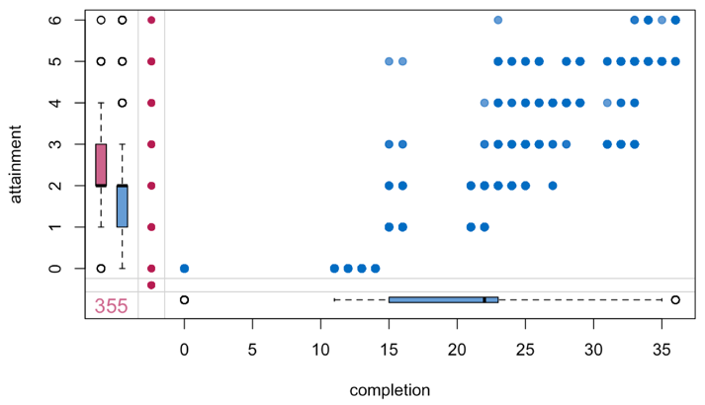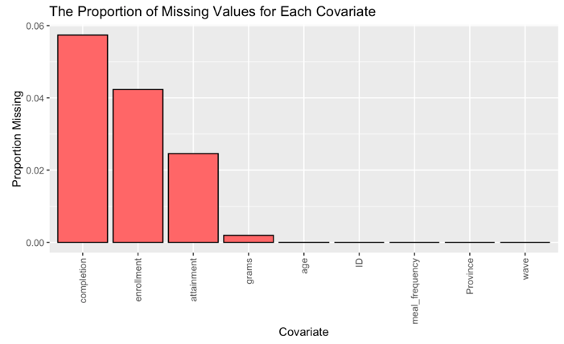

Figure 2: Missing Data by Covariate

Figure 3: Missingness Margin Plot

To preserve data and avoid introducing bias, Multiple Imputation using Chained Equations (MICE) was used to impute the missing data. The predictor matrix was specified using the “cart” methodology, and five imputations were conducted, with five iterations each. Once the fully imputed dataset was obtained, two batches of modeling were executed, with three regression models per batch, for a total of six regression models.

In the first batch of modeling, three regression models were run, corresponding to three different response variables, each telling their own story. The first response variable is enrollment, which provides insights on how a child’s nutrition impacts his/her decision to enroll in school in the first place. The second and third response variables are grade attainment and school completion, which provides insights on how a child’s nutrition impacts his/her ability to remain committed to learning and pursue education in the long-term, once he/she has enrolled.

The right-hand sides for these three regression models are identical. The primary explanatory variable is consumption, measured in grams per day. Exploratory data analysis of this variable yielded distributions with long right, justifying a log-transformation. Age and per capita income, which both have strong relationships with the response variables, were included as control variables. Exploratory data analysis of the per capita income variable also yielded distributions with long right tails, justifying a log-transformation. A fixed effect on *ID*, the unique identifier, was included to capture unobservable personal variability. A fixed effect on *WAVE*, the survey year, was included to capture unobservable variability over time and the longitudinal nature of the data. Finally, a fixed effect on *PROVINCE* was included to capture unobservable variability between provinces, as the wealthier municipality of Beijing most likely differs considerably from the poorer municipality of Guizhou.

The first batch of regression models can be generally formalized as follows:, where yit may represent probability of enrollment, highest grade level attained, or number of school years completed for their respective models.

In the second batch of modeling, three more models were run. The three response variables match those in the first batch, but the primary explanatory variable in this case is kilocalories. This batch of modeling tells a different story, providing insights on how the quality of a child’s daily consumption impacts his/her decision to enroll in school and pursue education in the long-term. Exploratory data analysis of the *kilocalories* variable yielded distributions with long right tails and notable outliers, justifying a log-transformation as well. Aside from the substitution of energy content for consumption as the primary explanatory variable, the rest of the right-hand side remains the same. Age and per capita income are maintained as relevant control variables. ID, WAVE, and PROVINCE are maintained as relevant fixed effects.

The second batch of regression models can be generally formalized as follows:

, where yit once again may represent probability of enrollment, highest grade attained, or number of school years completed for their respective models.

All three regression models were run on the complete merged dataframe, subset to the ages of 5-21, which the survey deemed to represent the potential “student population”.

Results

Below are the results of the fixed effects regression model where the response variable is probability of enrollment.

Figure 4: Consumption on Enrollment Regression Output

Figure 5: Consumption on Enrollment Marginal Effects Plot

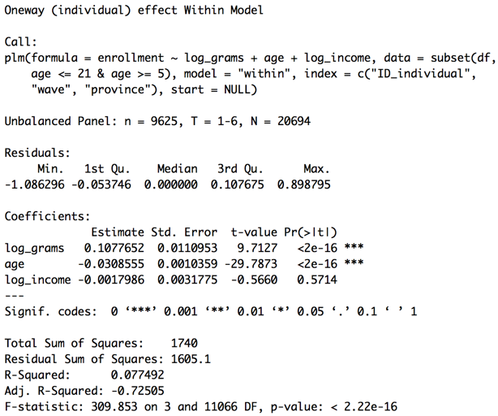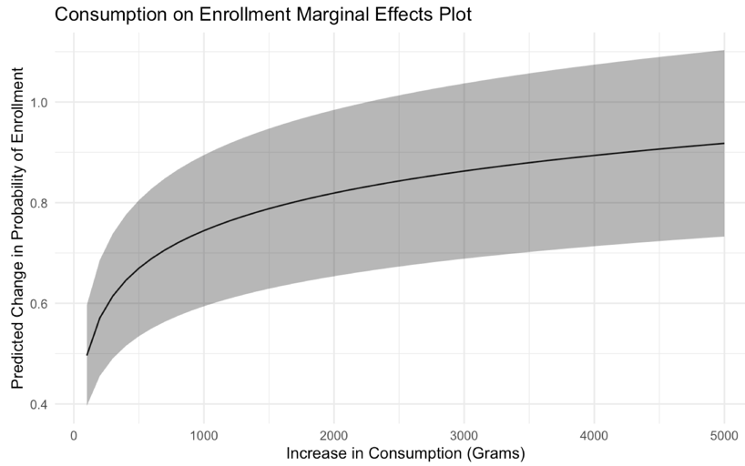

Figure 6: Energy on Enrollment Regression Output

Figure 7: Energy on Enrollment Marginal Effects Plot

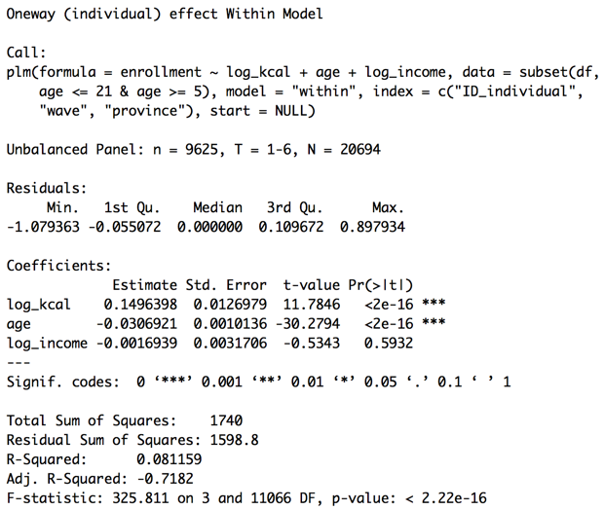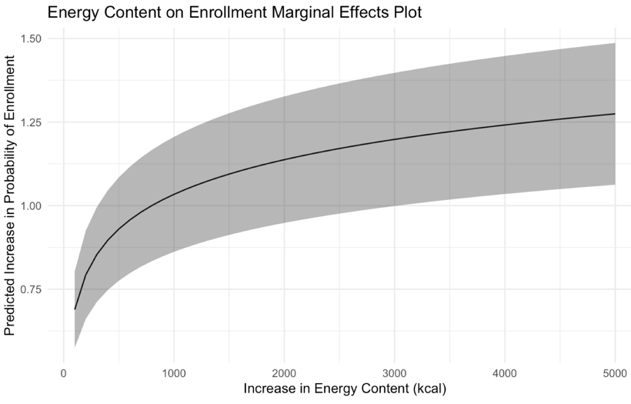

­

These two models posit a positive association between both quantity and quality of nutrition and enrollment. All else equal, a 50% increase in a child’s daily consumption in terms of grams and kilocalories is associated with a 4.37% and 6.07% increase in probability of that child enrolling, respectively. This effect is diminished by age and, surprisingly, per capita income. All else equal, increasing a child’s age by one year is associated with a 3.09% and 3.07% decrease in probability of that child enrolling, respectively. Increasing a child’s per capita income by 50% is associated with a 0.073% and 0.069% decrease in probability of that child enrolling, respectively. The marginal effects plot (Figure 5 and Figure 7) demonstrate that the positive impact of increasing both nutrition metrics on enrollment starts off relatively steep, then tapers off. All coefficients except for per capita income are significant to the to the .001 level.

Below are the results of the fixed effects regression model where the response variable is highest grade level attained.

Figure 8: Consumption on Attainment Regression Output

Figure 9: Consumption on Attainment Marginal Effects Plot

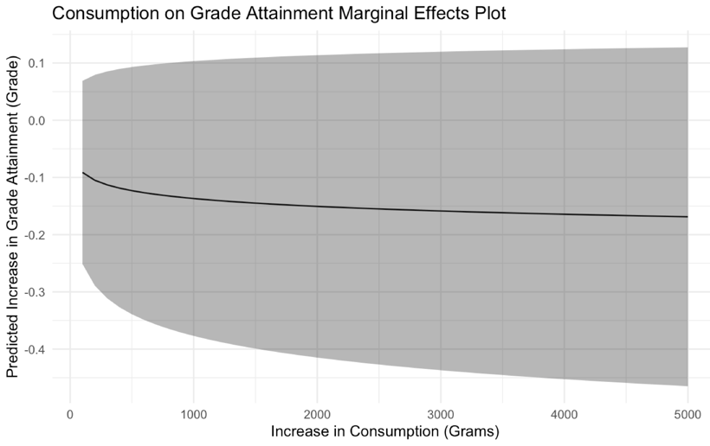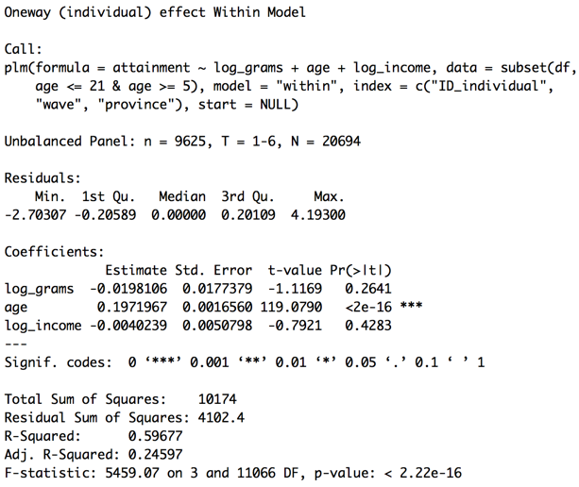

Figure 10: Energy on Attainment Regression Output

Figure 11: Energy on Attainment Marginal Effects Plot

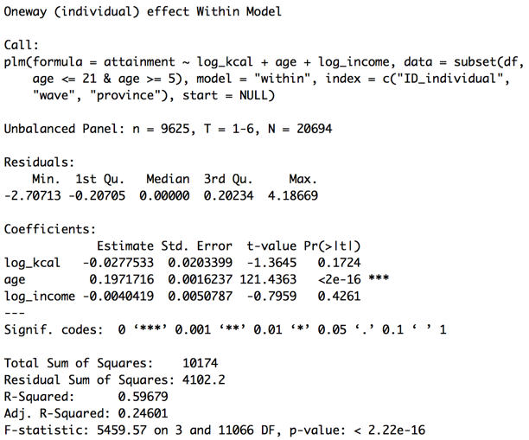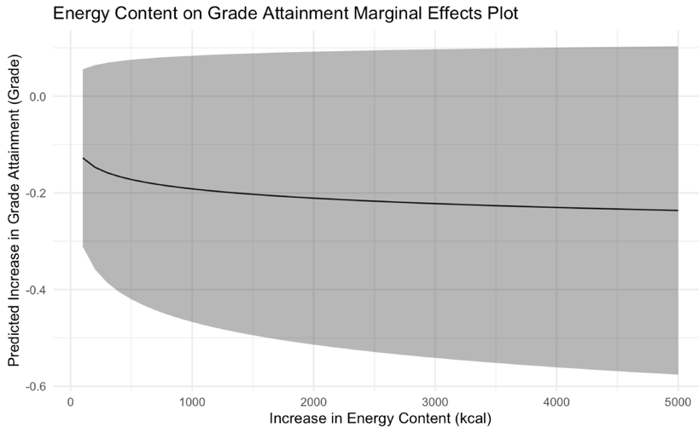

Surprisingly, these models posit a negative association between both quality and quantity of nutrition and attainment. All else equal, a 50% increase in a child’s daily consumption in terms of grams and kilocalories is associated with a 0.008 and .011 unit decrease in that child’s grade attainment, respectively. This effect is amplified by age and diminished by income. All else equal, increasing a child’s age by one year is associated with a 0.197 unit increase in that child’s grade level attainment in both models. Increasing a child’s per capita income by 50% is associated with a 0.002 unit decrease in that child’s grade attainment in both models. The marginal effects plots (Figure 9 & 11) demonstrate that the negative impact of improving both metrics of nutrition on grade attainment starts off relatively steep, then tapers off.

Below are the results of the fixed effects regression model where the response variable is number of school years completed.

Figure 12: Consumption on Completion Regression Output

Figure 13: Consumption on Completion Marginal Effects Plot

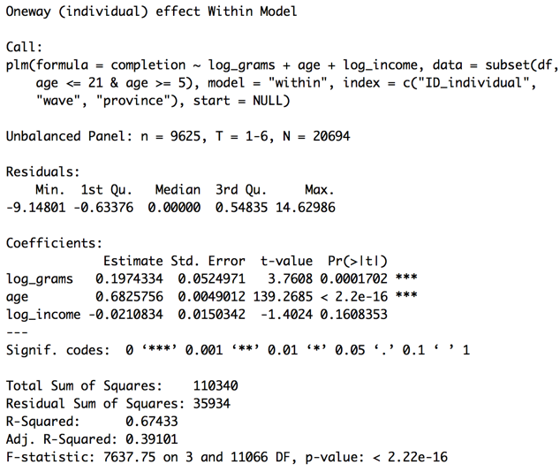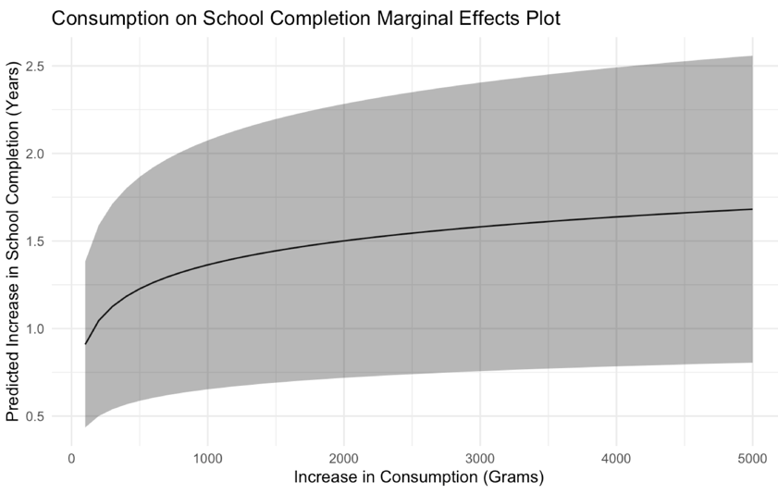

Figure 14: Energy on Completion Regression Output

Figure 15: Energy on Completion Marginal Effects Plot

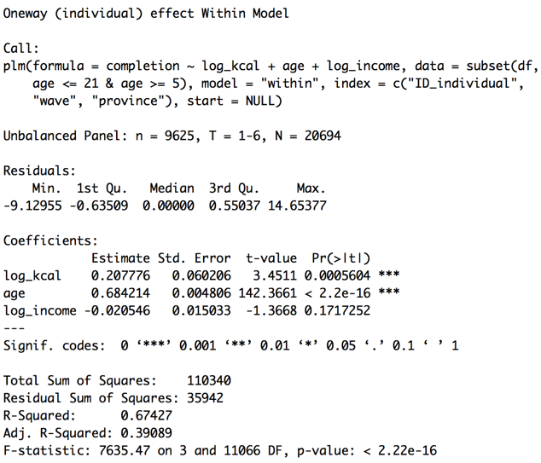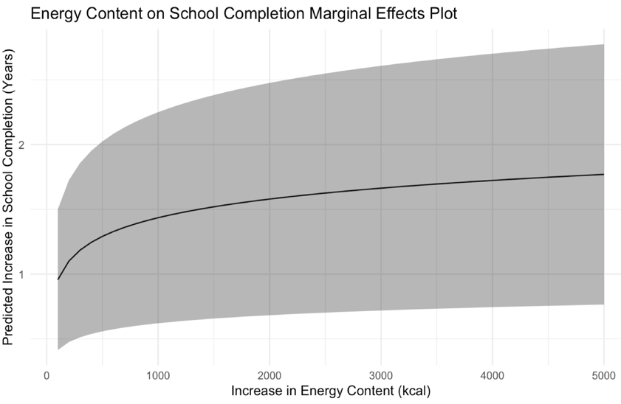

These two models posit a positive association between both quantity and quality of nutrition and school completion. All else equal, a 50% increase in a child’s daily consumption in terms of grams and kilocalories is associated with that child completing 0.080 and 0.084 more years of school, respectively. This effect is amplified by age and diminished by income. All else equal, increasing a child’s age by one year is associated with that child completing 0.68 more years of school in both models. Increasing a child’s per capita income by 50% is associated with that child completing 0.009 fewer years of school, respectively. The marginal effects plot (Figure 13 & 15) demonstrate that the positive impact of increasing consumption on school completion starts off relatively steep, then tapers off. All coefficients except for per capita income are significant on the .001 level.

The results form a compelling narrative about the role of nourishment in educational achievement. Increasing both consumption and energy content seem positively associated with both enrollment and school completion. This confirms the initial hypothesis that both eating more and eating better help a child to both make the initial decision to enroll in school and pursue learning in the long-term. With more sustenance and energy, the burdens of hunger and nutrition-related ailments are alleviated, and the child is more likely to perceive schooling as useful, leading to enrollment. Cognitive development and function are boosted, helping the child focus at school, earn better marks, and ascend through the educational system. As the marginal effects plots demonstrate, the marginal impact of each additional gram or kilocalorie consumed is initially sizeable, then gradually tapers off. This suggests to policymakers that school-meal programs that provide even a small nutritional boost may be the push that a breadth of potential students ultimately need to decide to enroll and remain in school.

On the third education metric, the regression model produced counterintuitive results that daily consumption measured in both grams and in kilocalories actually seem negatively associated with grade attainment. The results of the attainment model are complicated by several factors, primarily how the CHNS formulates the attainment variable. First, as mentioned before, the lowest category available for respondents is 1, corresponding to “graduated from primary school.” Respondents who never enrolled in school or never completed primary school, faced with no accurate answer choice, thus most likely skipped this portion of the questionnaire. With an inaccurate baseline level, even multiple imputation will return a dataset with a fundamentally flawed attainment variable.

Second, even the accurate response categories are not easily interpretable. Each “category” or “level” in this case represents an entire tier of education, ranging from primary school to graduate school. A variable formulated in such a way is very difficult to interpret in the continuous sense. For example, a hypothetical 0.1 unit increase is not a very meaningful result on a scale where “1” corresponds to “graduated from primary school” and “2” corresponds to “graduated from high school”.

Third, such a formulation, where one unit represents a cluster of grades, does not accurately represent a student’s learning. As Figure 16 demonstrates, a student who completed almost five years of school may still be attributed a “0” for grade attainment.

Figure 16: Completion vs. Attainment scatter plot

For all these reasons, compounded by the fact that the coefficients are both trivial and statistically insignificant on any reasonable confidence level, the attainment models are of less importance in this paper. If the education level clusters in the attainment variable were to be decomposed into its constituent grades to resolve some of these issues, the attainment variable would be largely redundant with the school completion variable. Thus, the paper focuses on the school completion model to quantify how nutrition impacts long-term learning.

The control variable coefficients add to the complexity of the story. With respect to age, the enrollment models inform us that older children are less likely to enroll in school, which can be explained by the fact that they experience both the pull factor of family obligations, such as farming or helping to run the family business, and the push factor of lower benefit of education, as an older child is likely to feel left behind by enrolling late. The other models, however, inform us that older children are associated with higher grade attainment and school completion. This makes sense, as older children have had more years to complete more years of school. The models could potentially be improved by modifying the age variable as time-elapsed-since-survey-entry to account for the natural increase in school attainment and completion over time.

The per capita coefficients seem to indicate the counterintuitive result that wealthier children are less likely to enroll in school. However, the per capita income variable is complicated by the nature of the data. As previously mentioned, household income is conceptualized as the sum of all sources of revenue minus expenditures. For many of these rural households, the primary revenue sources include raising livestock, farming, and gardening. Such activities are subject to annual weather differences, and market prices can swing drastically from positive in one year to negative in the next. As the project director noted: “It's normal that a person [who] invested big money in livestock or other businesses and earned nothing in one year, might gain or lose a lot in the second year. I heard such stories several times when I participated in data collection or supervised the fieldwork” (CHNS). Such variability may contribute to the inconsistent estimates on the per capita income coefficient. At any rate, all income coefficients were found to be both nontrivial and statistically insignificant.

Limitations

This paper cannot establish a causal impact of undernourishment on educational achievement, due to several limitations.

The primary limitation is omitted variable bias. While age and per capita income are certainly highly relevant control variables, and the fixed effects on individuals, survey years, and provinces are useful in resolving omitted variable bias attributable to unobservable variation between individuals, over time, and across demographic boundaries, many relevant time-varying control variables have undoubtedly been left out of the models. For example, hours spent doing housework per day may be a relevant control variable that is correlated to both the explanatory variable consumption and all of the education response variables, as children who devote much of their time to family obligations are less likely to enroll in and commit in the long term to school. Access to healthcare services may be another relevant control variable, as children who are dealing with preexisting medical conditions are less likely to both enroll in and commit in the long term to school. Parental education may be another relevant control variable, as children in educated families may be encouraged to enroll and pursue higher education themselves.

Many of these omitted variables were not collected by the CHNS, and those that were had too much missing data to be included in the regression models. Other variables such as innate intellectual ability are important control variables, but simply impossible to quantify and measure. Either way, these omitted variables may systematically bias the model by incorrectly attributing their effects to those of the included variables. If not interpreted cautiously, such model results could persuade policymakers to invest in programs that attempt to improve the current nourishment of school-age children even though programs that focus on infants and very young children may be more effective.

A second limitation arises from the possibility of measurement error. This is particularly problematic for the primary explanatory variables of daily consumption and energy content, which are self-reported. It is hard to imagine that anyone is able to measure grams accurately, much less kilocalories. Thus, estimates are likely to suffer from bias towards zero (if measurement error is classical) or bias in an unknown direction (if measurement is nonclassical, which is plausible in this context of retrospective nutrition and education reports). For example, it is possible that respondents consistently underreport their dietary intake. Such non-classical measurement error may lead to systematically biased estimates.

A third limitation resides within the mechanics of regression modeling. In both batches of regression modeling, for the two models related to enrollment, it would seem more intuitively suitable to use a logistic regression link function, seeing as the response variable is a binary 0 vs. 1 factor variable. However, the pglm package in R is unable to effectively deal with a conditional logistic model with multiple fixed effects, as the maximum likelihood estimation method runs out of iterations and does not converge to a global optimum. Thus, a linear regression link function was used. As a result, while the interpretability of the model is not compromised, the predictive power of the model is particularly weak for children at the tails of the distribution. That is to say, the model may yield nonsensical probabilities of enrollment less than 0 or greater than 1 for children who, a priori to a modification in their diet, were either extremely unlikely or likely to enroll in school, respectively.

A fourth limitation relates to the individuals who were included in the survey. Perhaps due to the One Child Policy, young children are underrepresented and adults are overrepresented. The average age of individuals surveyed is about 44 years old. Out of 64,456 individuals, only 3,957, or about 6%, are between the age of 5 and 21. In particular, across all the waves, only two 5-year old children, eleven 6-year old children, and sixteen 7-year old children were surveyed. The under-sampling of children who are at the ages most likely to enroll may systematically bias the estimates of the regression.

A fifth limitation is that of reverse causality. The regression models found in this paper posit that the explanatory variable of consumption impacts the response variable of educational outcome. However, the reverse relationship also exists – that of educational outcomes on consumption. For example, good nourishment may lead to enrollment in wave T. Once enrolled, the child may encounter nutritional education classes, which may then lead to better nourishment in wave T+1. This reverse causality may lead to biased results. Such bias can be ameliorated by incorporating temporal lags, which is outside the scope of this paper.

These problems are not easy to fix and highlight the broader issues that complicate the study of the relationship between nourishment and education. However, taking such limitations into account, this paper is a fair justification for at least a strong relationship between proper nourishment and educational outcomes.

**References**

ACC/SCN (2000) Fourth Report on the World Nutrition Situation. Geneva: ACC/SCN in

     collaboration with IFPRI.

Behrman, Jere R., and Anil B. Deolalikar. “Chapter 14 Health and Nutrition.” *Handbook of Development Economics*, 1988, pp. 631–711., doi:10.1016/s1573-4471(88)01017-4.

“China Health and Nutrition Survey.” *China Health and Nutrition Survey - China Health and Nutrition Survey (CHNS)*, www.cpc.unc.edu/projects/china.

“China Nutrition Profile.” *Global Nutrition Report*, 23 Mar. 2020, globalnutritionreport.org/resources/nutrition-profiles/asia/eastern-asia/china/.

Glewwe, Paul, and Edward A. Miguel. “Chapter 56 The Impact of Child Health and Nutrition on Education in Less Developed Countries.” *Handbook of Development Economics*, 2007, pp. 3561–3606., doi:10.1016/s1573-4471(07)04056-9.

Grantham-Mcgregor, S M, et al. “Effects of Early Childhood Supplementation with and without Stimulation on Later Development in Stunted Jamaican Children.” *The American Journal of Clinical Nutrition*, vol. 66, no. 2, Jan. 1997, pp. 247–253., doi:10.1093/ajcn/66.2.247.

Jamison, and Dean. “Child Malnutrition and School Performance in China.” *Journal of Development Economics*, 12 July 2010, documents.worldbank.org/curated/en/128171468025473064/Child-malnutrition-and-school-performance-in-China.

Kearney, John. “Food Consumption Trends and Drivers.” *Philosophical Transactions of the Royal Society B: Biological Sciences*, vol. 365, no. 1554, 2010, pp. 2793–2807., doi:10.1098/rstb.2010.0149.

Leslie, Joanne, and Dean T. Jamison. “Health and Nutrition Considerations in Education Planning. 1. Educational Consequences of Health Problems among School-Age Children.” *Food and Nutrition Bulletin*, vol. 12, no. 3, 1990, pp. 1–13., doi:10.1177/156482659001200305.

Luo, Renfu, et al. “Nutrition and Educational Performance in Rural China’s Elementary Schools: Results of a Randomized Control Trial in Shaanxi Province.” *Economic Development and Cultural Change*, vol. 60, no. 4, 2012, pp. 735–772., doi:10.1086/665606.

Mendez, Michelle A., and Linda S. Adair. “Severity and Timing of Stunting in the First Two Years of Life Affect Performance on Cognitive Tests in Late Childhood.” *The Journal of Nutrition*, vol. 129, no. 8, Jan. 1999, pp. 1555–1562., doi:10.1093/jn/129.8.1555.

Roser, Max, and Esteban Ortiz-Ospina. “Global Education.” *Our World in Data*, 31 Aug. 2016, ourworldindata.org/global-education.

Rosso, Joy Miller Del, and Tonia Marek. “Class Action.” 1996, doi:10.1596/0-8213-3672-x.

“SOFI 2019 - The State of Food Security and Nutrition in the World.” *Www.fao.org*, www.fao.org/state-of-food-security-nutrition/en/.

Todd, Jessica E., and Paul Winters. “The Effect of Early Interventions in Health and Nutrition on On-Time School Enrollment: Evidence from the Oportunidades Program in Rural Mexico.” *Economic Development and Cultural Change*, vol. 59, no. 3, 2011, pp. 549–581., doi:10.1086/658347.

“World Hunger, Poverty Facts, Statistics 2018.” *World Hunger News*, www.worldhunger.org/world-hunger-and-poverty-facts-and-statistics/.

1. The 4th Report of the World Nutrition Situation defines stunting as low height−for−age at < −2 standard deviations (SD) of the median value of the National Center for Health Statistics/World Health Organization (NCHS/WHO) international growth reference.
2. The 4th Report of the World Nutrition Situation defines wasting as low weight−for−height at < −2 SD of the median value of the NCHS/WHO international weight−for−height reference.